EXP NO:1B-CHARACTERISTICS STUDY OF SIDE BAND POWER ANDFREQUENCIES IN AM USING MATLAB
AIM: To generate an Amplitude Modulated (AM) signal in MATLAB using specified carrier and modulating signal parameters
clc;
clear;
close all;
Am = 2;
fm = 600;
Ac = 6;
fc = 6000;
fs = 30*fc;
t = 0:5/fs:4/fm;
m = Am*sin(2*pi*fm*t);
c = Ac*sin(2*pi*fc*t);
mu = Am/Ac;
am = Ac*(1 + mu*sin(2*pi*fm*t)).*sin(2*pi*fc*t);
dem = abs(hilbert(am));
dem = dem - mean(dem);
N = length(am);
f = linspace(-fs/2, fs/2, N);
AM_FFT = abs(fftshift(fft(am)))/N;
USB = fc + fm;
LSB = fc - fm;
Pc = Ac^2/2;
Psb = (mu^2*Pc)/4;
figure('Name','AM Modulation','NumberTitle','off');
subplot(3,2,1);
plot(t,m);
title('Message Signal');
grid on;
subplot(3,2,2);
plot(t,c);
title('Carrier Signal');
grid on;
subplot(3,2,3);
plot(t,am);
title('AM Signal');
grid on;
subplot(3,2,4);
plot(t,dem);
title('Demodulated Signal');
grid on;
subplot(3,2,5);
plot(f,AM_FFT);
xlim([fc-3*fm fc+3*fm]);
title('Frequency Spectrum');
xlabel('Frequency (Hz)');
ylabel('Magnitude');
grid on;
subplot(3,2,6);
bar([Pc Psb Psb]);
set(gca,'XTickLabel',{'Carrier','USB','LSB'});
title('Power Distribution');
ylabel('Power (W)');
grid on;
fprintf('mu = %.2f | USB = %d Hz | LSB = %d Hz | Pc = %.2f W | Psb = %.3f W\n', ...
mu, USB, LSB, Pc, Psb);
OUTPUT (GRAPH):
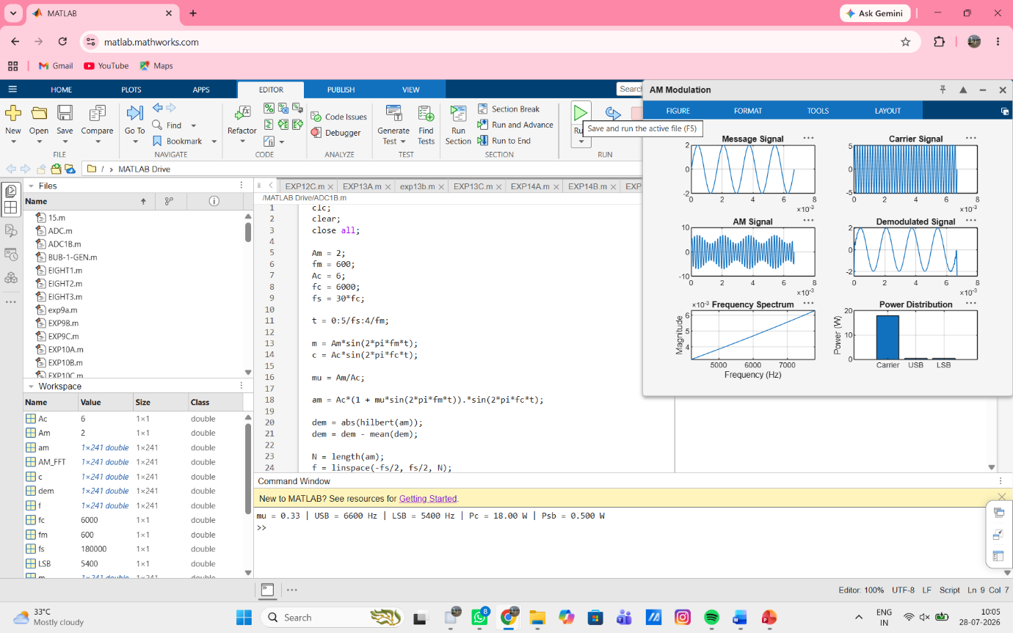
RESULT:
The AM signal was successfully generated and analyzed in MATLAB.

